Table of Contents
Table of Contents 1
List of Figures 1
Race History 2
Introduction 4
Chassis Layout 6
Budget: 18
SUSPANSION PARTS (drawings) 22
Chassis 24
Strut 25
Lower A-arm 26
Upper Link 26
Rotational Link 27
Hymne Joint 27
Figure 17 27
Shim 28

List of Figures
Figure 1: Double A-arm independent suspension, with a coil-over shock 4
Figure 2: Top view of the newly designed solar car (SunsationII) 6
Figure 3: Cross section area along with preliminary dimensions (in mm and in). 7
Figure 4: Front cross-section view of newly designed solar car (SunsationII) 7
Figure 5: Side view of newly designed solar car (SunsationII) 8
Figure 6: Schedule of the project, created using primavera 9
Figure 7: 2D drawing of first concept design of suspension. 12
Figure 8: 2D drawing of second concept design of suspension. 13
Figure 9: Geometric sketch for concept 2, of how distances, lengths, and angles were determined. 14
Figure 10: 2D drawing of final design concept of suspension. 15
Figure 11: Geometric sketch of final design; distances, lengths, and angles. 16

Race History
When adventurer Hans Tholstrup and motor racing legend Larry Perkins first crossed Australia from West to East in a fragile vehicle powered by the sun in 1983, no-one would have guessed that it would lead to the creation of the world's most prestigious solar car race. Four years later, 23 solar powered cars from seven countries set off from Darwin bound for Adelaide in the first World Solar Challenge.
The event was definitely a success, helped along by the performance of General Motor's "Sunraycer" that surprised experts with its average speed for the journey of close to 67 kph. In turn, the event marked the dawn of a new beginning.
In the following years to come, the event only got better. In 1990 there were 36 starters, with the winner being an entry from the Swiss Engineering School, Biel. And in 1993, the race was astounded by 53 entries in a race that was dominated by the high-tech Honda Dream that took the honors at an average speed of 85 kph.
With this great history of a new beginning, it is definitely no surprise to see all of the competitive cars battle for pride and bragging rights in The World Solar Challenge.
The World Solar Challenge is recognized internationally as THE premier solar car event, and is the only open road race not run in stages. It is also the only event that crosses a continent and is seen as the ultimate test for amazing examples of technology and team ingenuity. It is held every third year in Australia. The track is 3000 km long and goes from Darwin in the north to Adelaide in the south.
The "World Solar Challenge", as the race is called, was founded by the Dane Hans Tholstrup, who in 1981 build the first solar car of the world and crossed the Australian continent.
Unfortunately, we as college students have our own competition in solar car racing. And though it may not be as prestigious as The World Solar Challenge, we have just as much fun battling to be the best solar car team in the race.

Introduction
This year our team of mechanical engineers was asked to design the front suspension of a new car called Sunsation II. The project was then divided into two stages. The first stage of our design included the following: Determine shock/spring configuration, determine steering mechanism and characteristics, analyze design for loading and conformance to specs, write preliminary design report, drawings completed, and have parts on hand or on order by 12/1/00. The second phase of this project was to include assembling, analyzing performance, and analyzing composite material.
In summary, the first stage consisted of learning techniques on how to develop a scheduling chart and budget for the project. Some preliminary drawings along with a WBS chart were also included in the list of tasks to be completed.
The following is an example of one of the first concepts considered by the team.

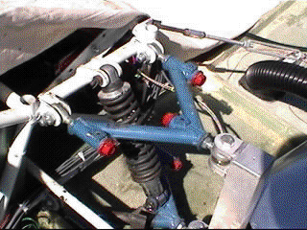

Figure 1: Double A-arm independent suspension, with a coil-over shock
Figure1 shows a double A-arm independent suspension, with a coil-over shock. Once the main operations of this design were understood our team discussed the likes and dislikes with our team sponsor (Dr Harrison). A composite list of the likes and dislikes can be found below.

Prior design likes
- camber adjustment
- caster adjustment
- toe/in toe out adjustment
- simplistic yet effective design

Prior design dislikes
- weight of suspension components
- bulky coil over shock
- difficult to adjust
- wheel scrub
- difficult to work on

From Figure 1 above, we were able to develop a new design that everyone agreed upon.
As for the specifications, our sponsor wanted a design that was light in weight and not as large as the previous front suspension. With so many changes amongst this year’s chassis design, we were forced to modify our new design based on the chassis specifications below.

Chassis Layout
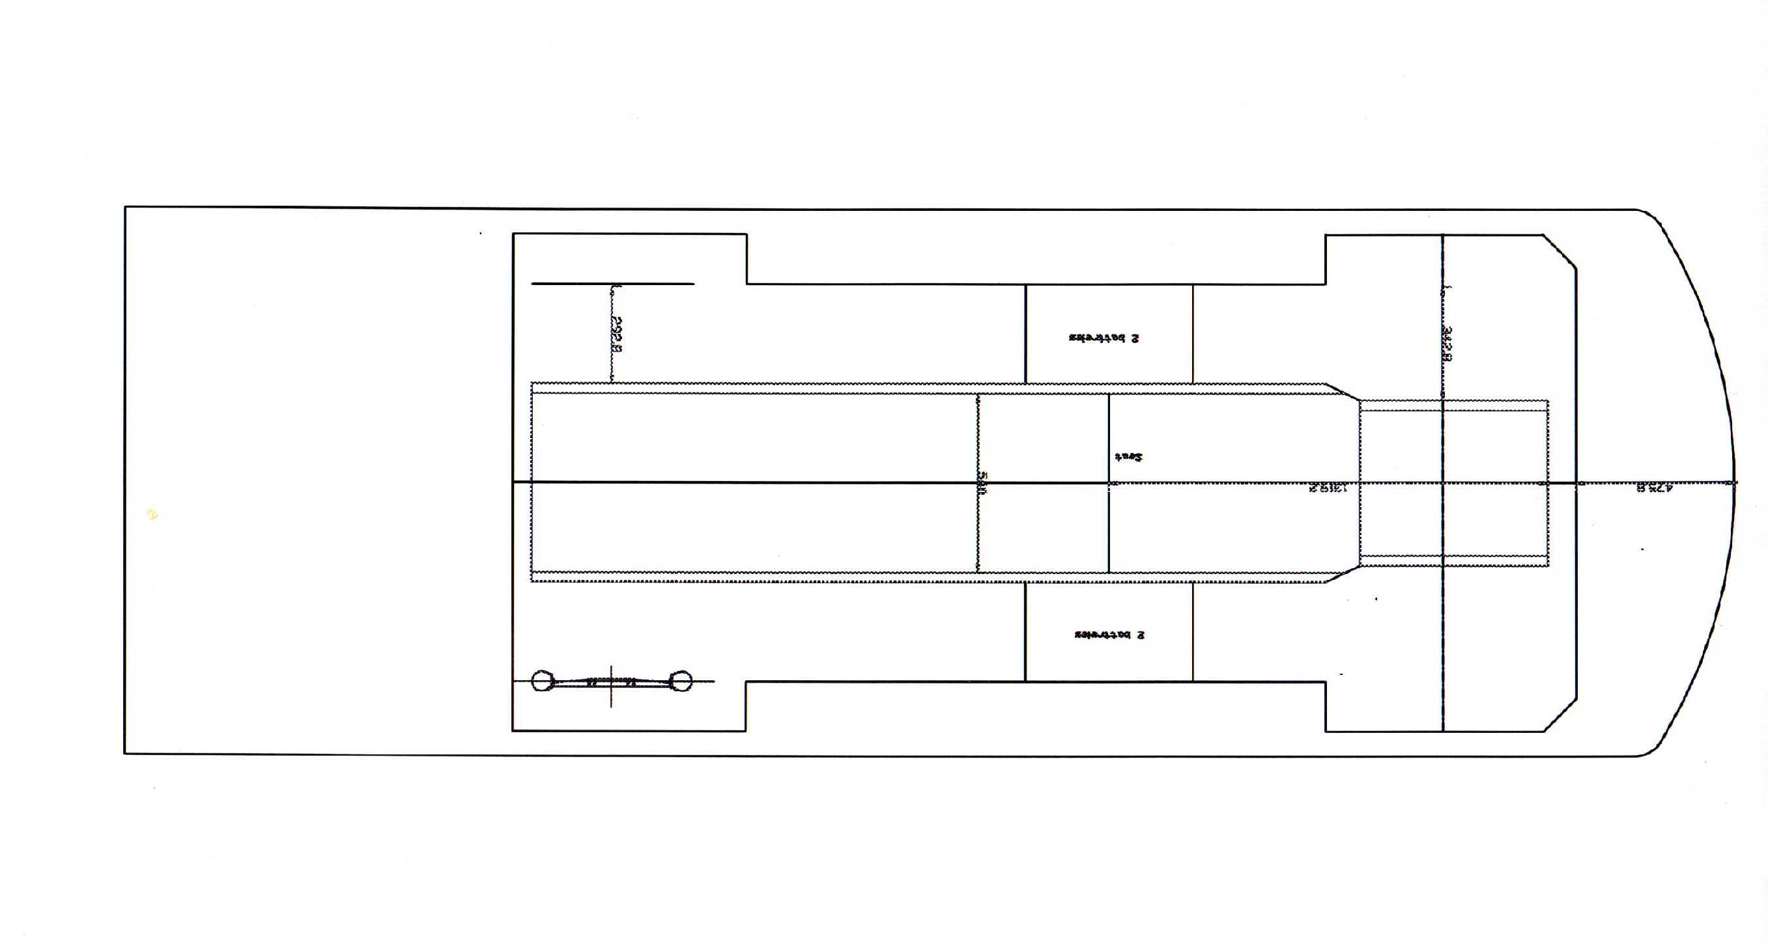
Figure 2: Top view of the newly designed solar car (SunsationII)

Figure 2 shows the actual top view of this newly designed solar car body. A clearer picture of this view can be seen in the appendix A.
The next task entailed designing a new suspension and incorporating it into the new body layout seen above. In Figure 2 (appendix A1), the front section of the car was the specified design area for the new front suspension. A closer view of the design area can be viewed in Figure 3. Figure 3 (appendix A2) shows the design area along with preliminary dimensions (in mm and in).

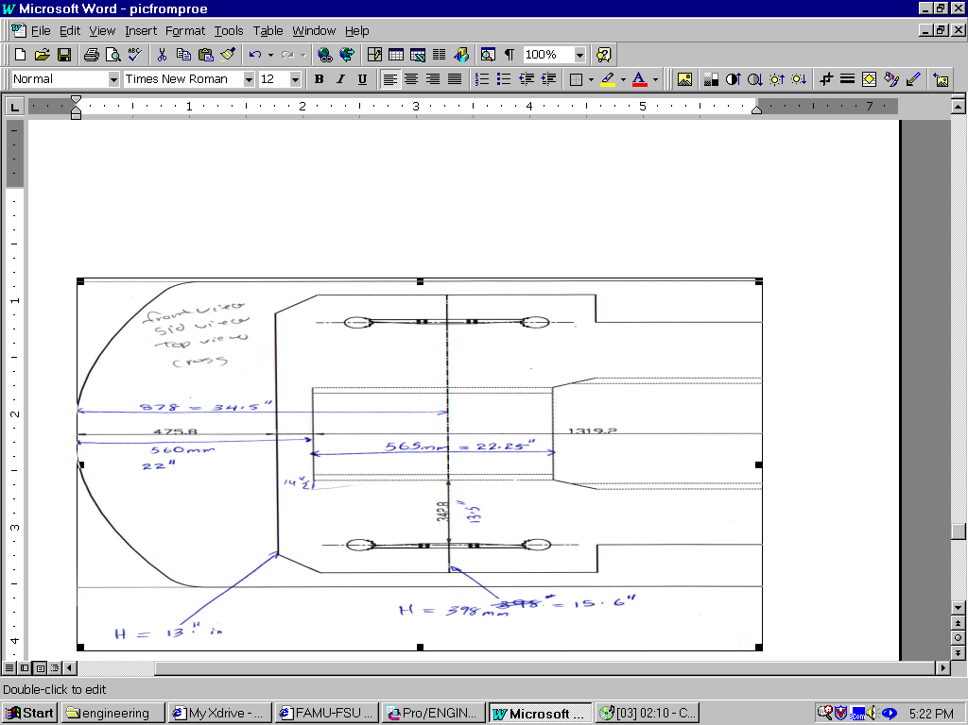

Figure 3: Cross section area along with preliminary dimensions (in mm and in).

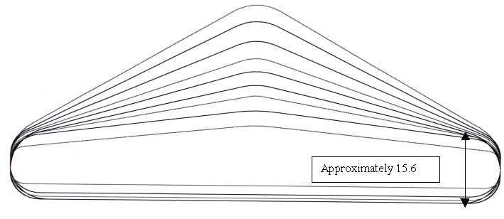

Figure 4: Front cross-section view of newly designed solar car (SunsationII)

Figure 4 illustrates the maximum amount of travel our suspension design is allowed be fore collision with the solar array occurs. The figure also shows the profile of the body design, an airfoil design is used to minimize when resistance, which in turns decreases drag, increases performance, and conserves energy.

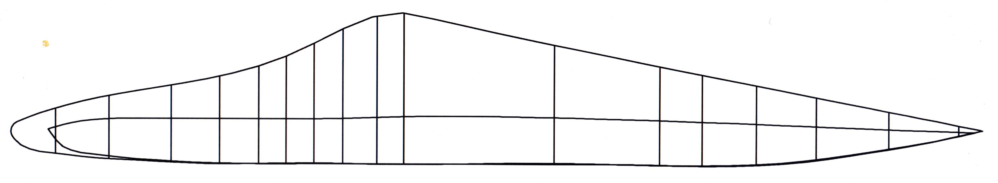

Figure 5: Side view of newly designed solar car (SunsationII)

Figure 5 (appendix A4) shows the side view of the new design. The vertical lines in the drawing illustrate the actual cross section areas seen in Figure 4. These cross sections are incorporated not only for the sectional dimension areas needed to help all the groups in their design, but also for a layout of structural design to support the honeycomb unibody design.

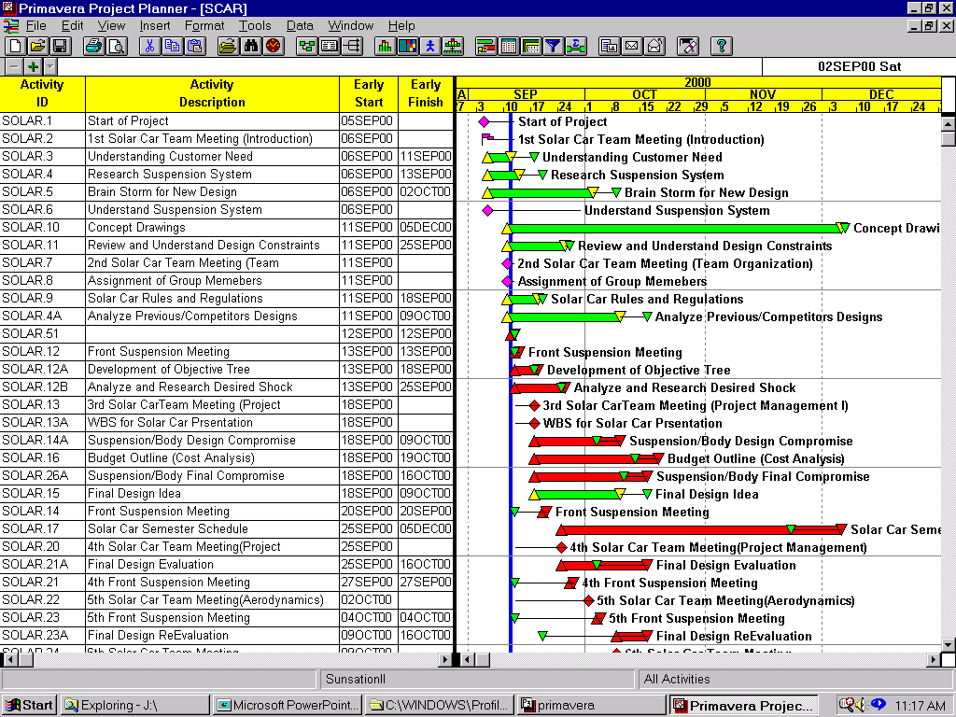Schedule
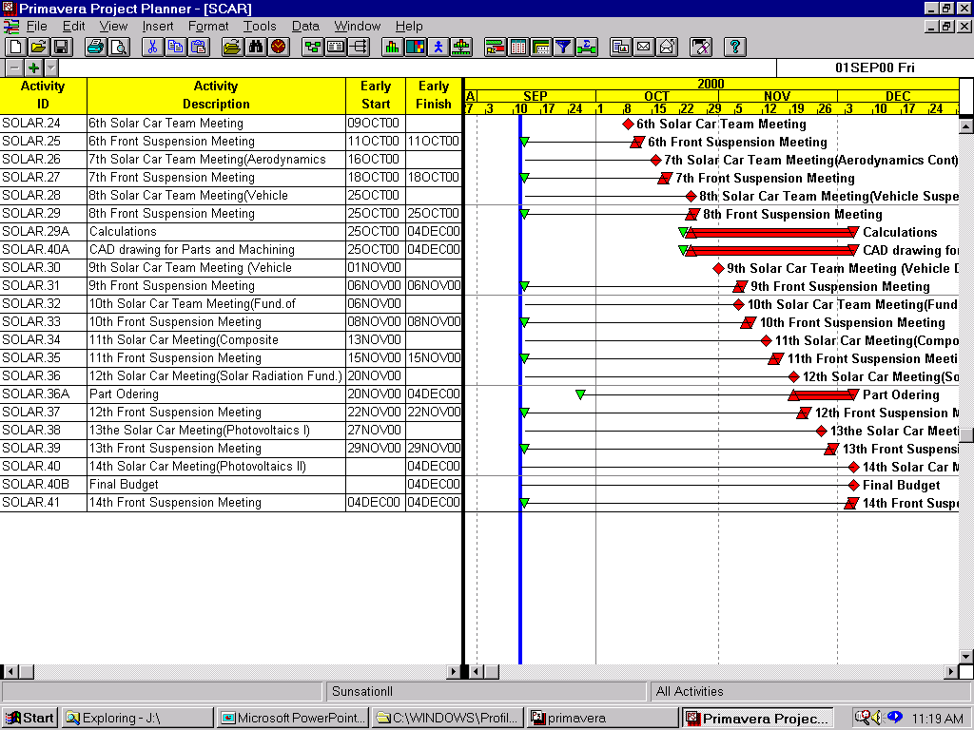

Unfortunately, because of some changes, the entire solar team was forced behind schedule, so design building and assembly will not begin until next year. In turn, we did not stay on schedule as expected for the second phase. Here is a schedule of events that took place during the first stage.
Figure 6: Schedule of the project, created using primavera

Figure 6 includes the schedule of the project, created using primavera. Some of the main points included are the weekly solar team and front suspension team meetings. The solar team meetings provided a chance for all the groups to report progress. There were also weekly lectures by professors. The topics covered were suspension design, material selection, scheduling, and aerodynamics. The weekly meetings for the front suspension team were used to brainstorm concepts, and solve problems. Several of these meetings were with the SAE team, which provided valuable information concerning shock selection and suspension geometry.
In addition, our sponsor also invited guest speakers to give us insight on various concepts that we may or may not have understood at that particular time. We were also given the opportunity to read various books on solar cars, so that we could gain important background information concerning the developmental design of solar cars.

Conceptual Designs

First Design Concept
One of our main specifications was to obtain at least 6 in. of travel in the vertical direction. To attain this, we decided to use rocker arm and control arms in our. This initial idea consisted of a double A-arm independent suspension. This design would consist of a rocker on the shock and arm, which would enable us to achieve the desired travel of 6 inches from the short travel of 1.5 in on the shock, 3” in both y and the –y direction. The max width of the car is 1.65 cm, so in order to get 6 inches of travel from the suspension the shocks are mounted inside of the chassis. From the shock and rocker a tie rod is used to translate the vertical displacement from the wheel hub to the shock. This tie rod can also be use to adjust the ride height of the car along with the adjustable shock. One main design includes A-arms constructed of the same threaded rod used in the damper rod. This design was used in the SAE car with excellent performance.
Initially this design appeared that it would work and would be very efficient. However it would not be deemed acceptable due to area constraints that may compromise the main body design and question of efficiency with cycling of the suspension. This concept can be seen in Figure 7 (appendix B1) to give a visional feel for the design.

Figure 7: 2D drawing of first concept design of suspension.
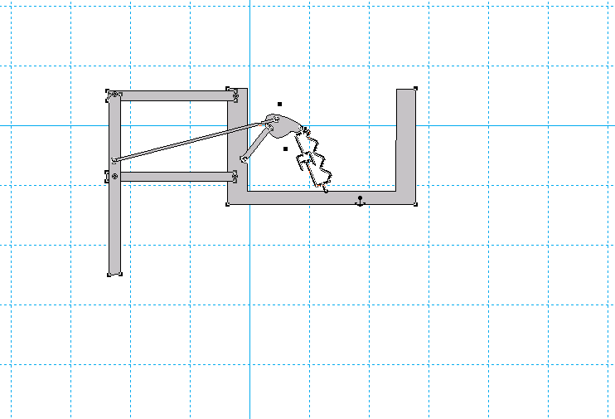
Second design concept
With this design, we would still be able to obtain the design specifications, like that of the first design. 6in of travel, lightweight, adjustable for camber, caster, toe in/out, and reduce scrub. However with this new design no rocker arm or tie rod was needed to obtain our desired specifications. This design would incorporate the shock directly mounted on the double A-arm suspension. The shock would be mounted about 2in off of the composite body directly to the bottom A-arm and rigidly connected to the composite body. A 2D drawing of this design can be seen below in figure 8.
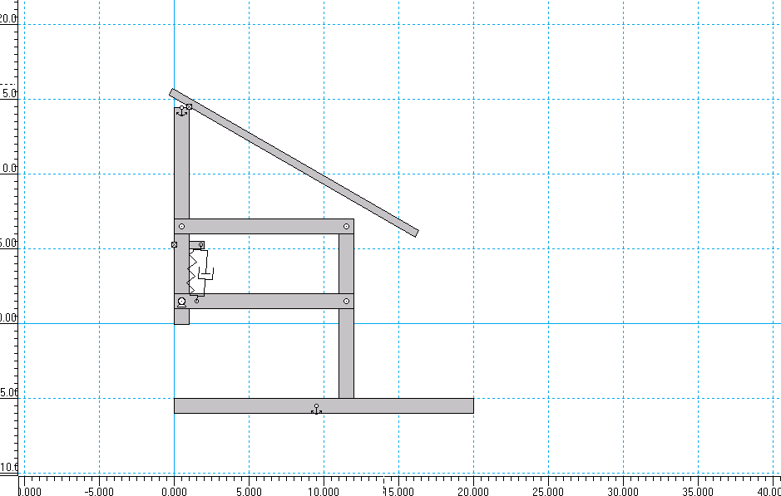

Figure 8: 2D drawing of second concept design of suspension.

Now in order to obtain the 6 in. of travel with a shock that only has 1.5 in travel, we had to calculate how long the A-arms would be and also how much separation between the A-arms were needed achieve the travel high and still have maximum shock efficiency. Through some minor geometric calculations we were able get the approximate arm length and distance between them. This can be seen in Figure 9 (appendix B). With this design, we still had to deal with the problem of travel clearance for the suspension. This secondary design was determined to be well thought-out and producible but still needed some fine-tuning to obtain and maximize the travel clearance.
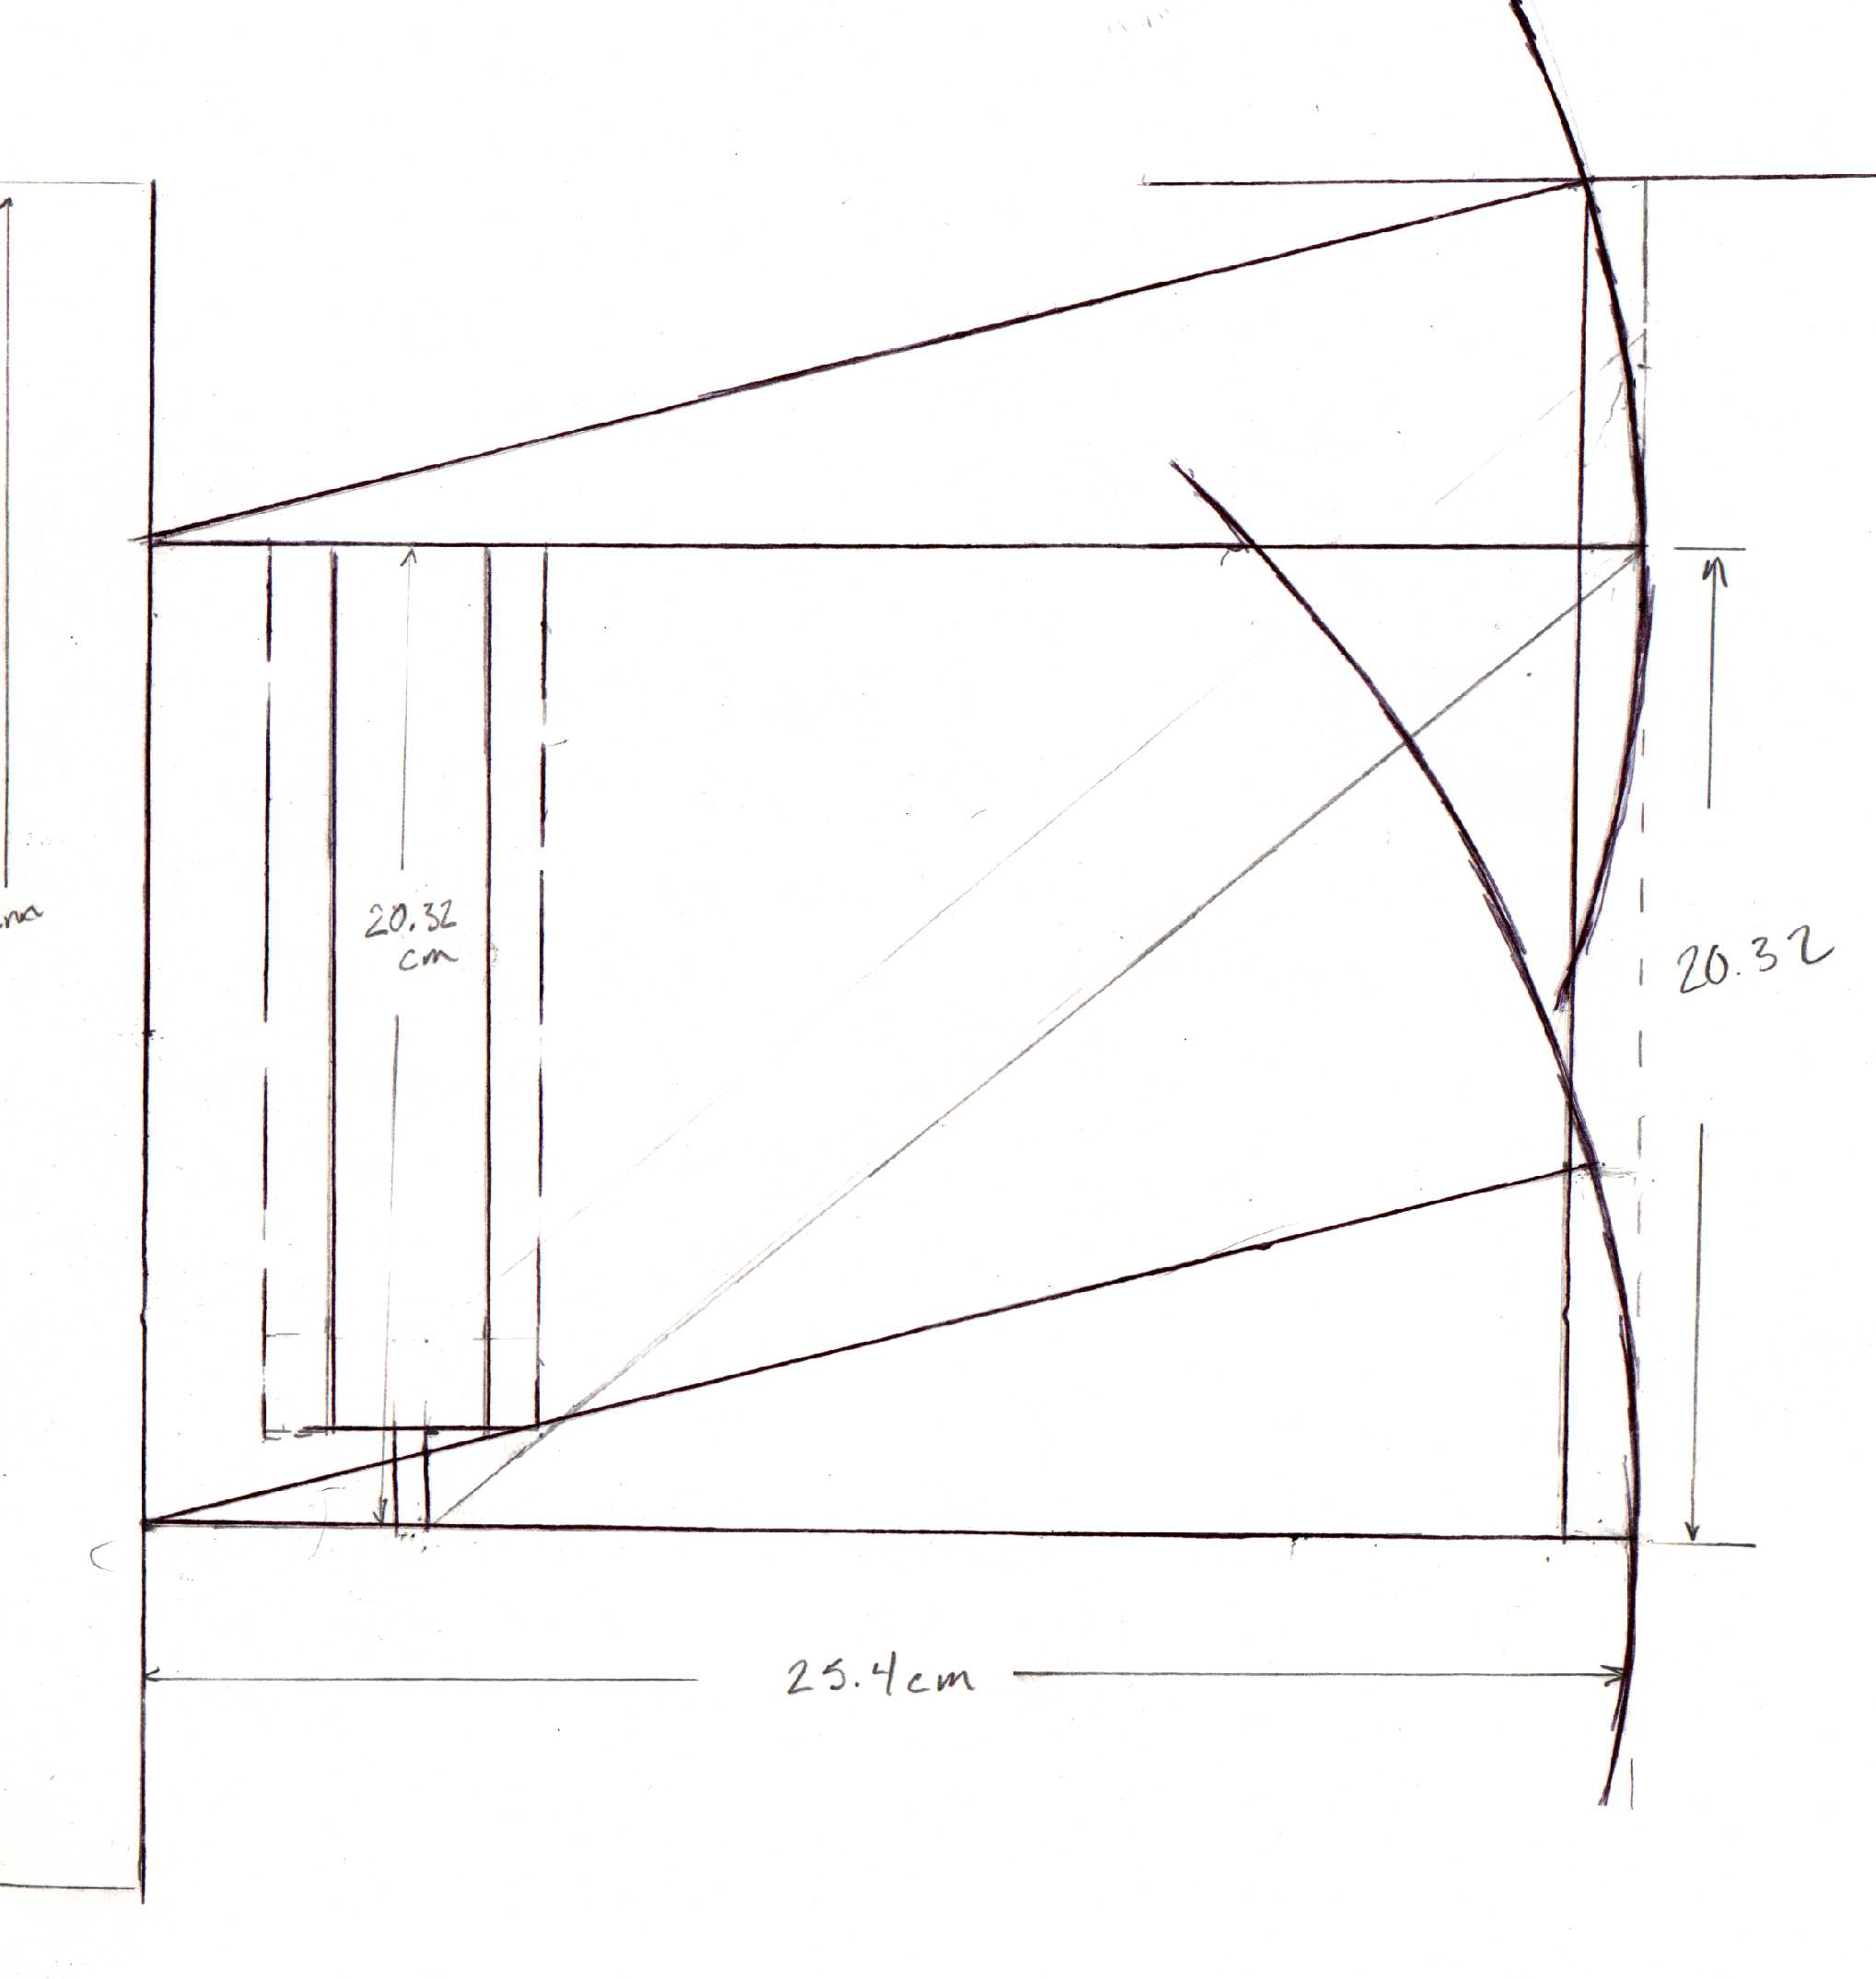
Approximately 16 degrees
1in scrub
Figure 9: Geometric sketch for concept 2, of how distances, lengths, and angles were determined.

Final design concept
After some long and stressful brain storming, a final idea arose on how to deal with the travel clearance for the system. This idea, which was just a trial assumption, was analyzed and confirmed through some research done by one of our professors, Dr. Hollis. This trial idea not only solved our clearance problem but also simultaneously decreased our scrub problem (about .5in decrease) associated with our tires and the travel displacement of the suspension system (moving up and down). This new design consisted of shortening our upper A-arm and implementing a slight angle at the top of connection arm (wheel assembly to suspension system). Figure 10 will give you a better view of how our secondary concept was redesigned to achieve our primary specifications for the front suspension.
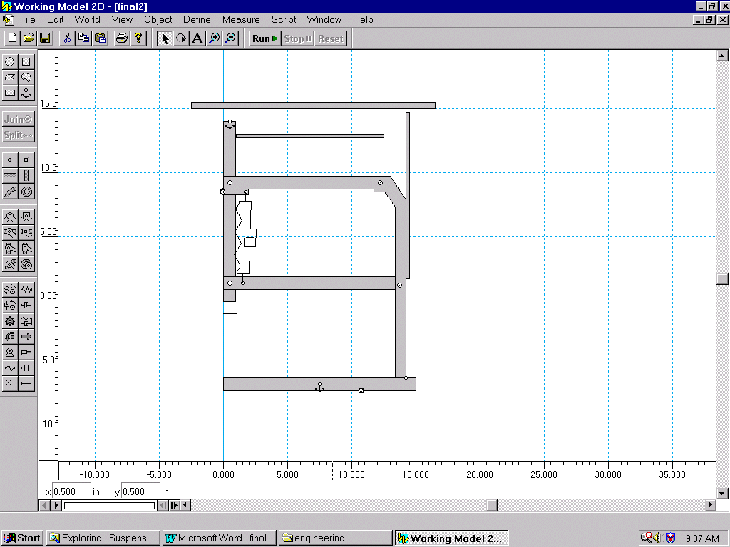
Figure 10: 2D drawing of final design concept of suspension.
With our final design concept, we also had to obtain the 6in of travel with a shock that only has 1.5-in travel. To do this, our design proposes a connection arm, with an angle of about 60 degrees to subtract from total length and degrees the length of the upper A-arms. This design simultaneously helps degrees scrub on the front tires. We performed the same minor geometric calculations on how long the A-arms would be and also how much separation between the A-arms were needed achieve the travel high and still have maximum shock efficiency. This can be seen in figure 11 (appendix B).
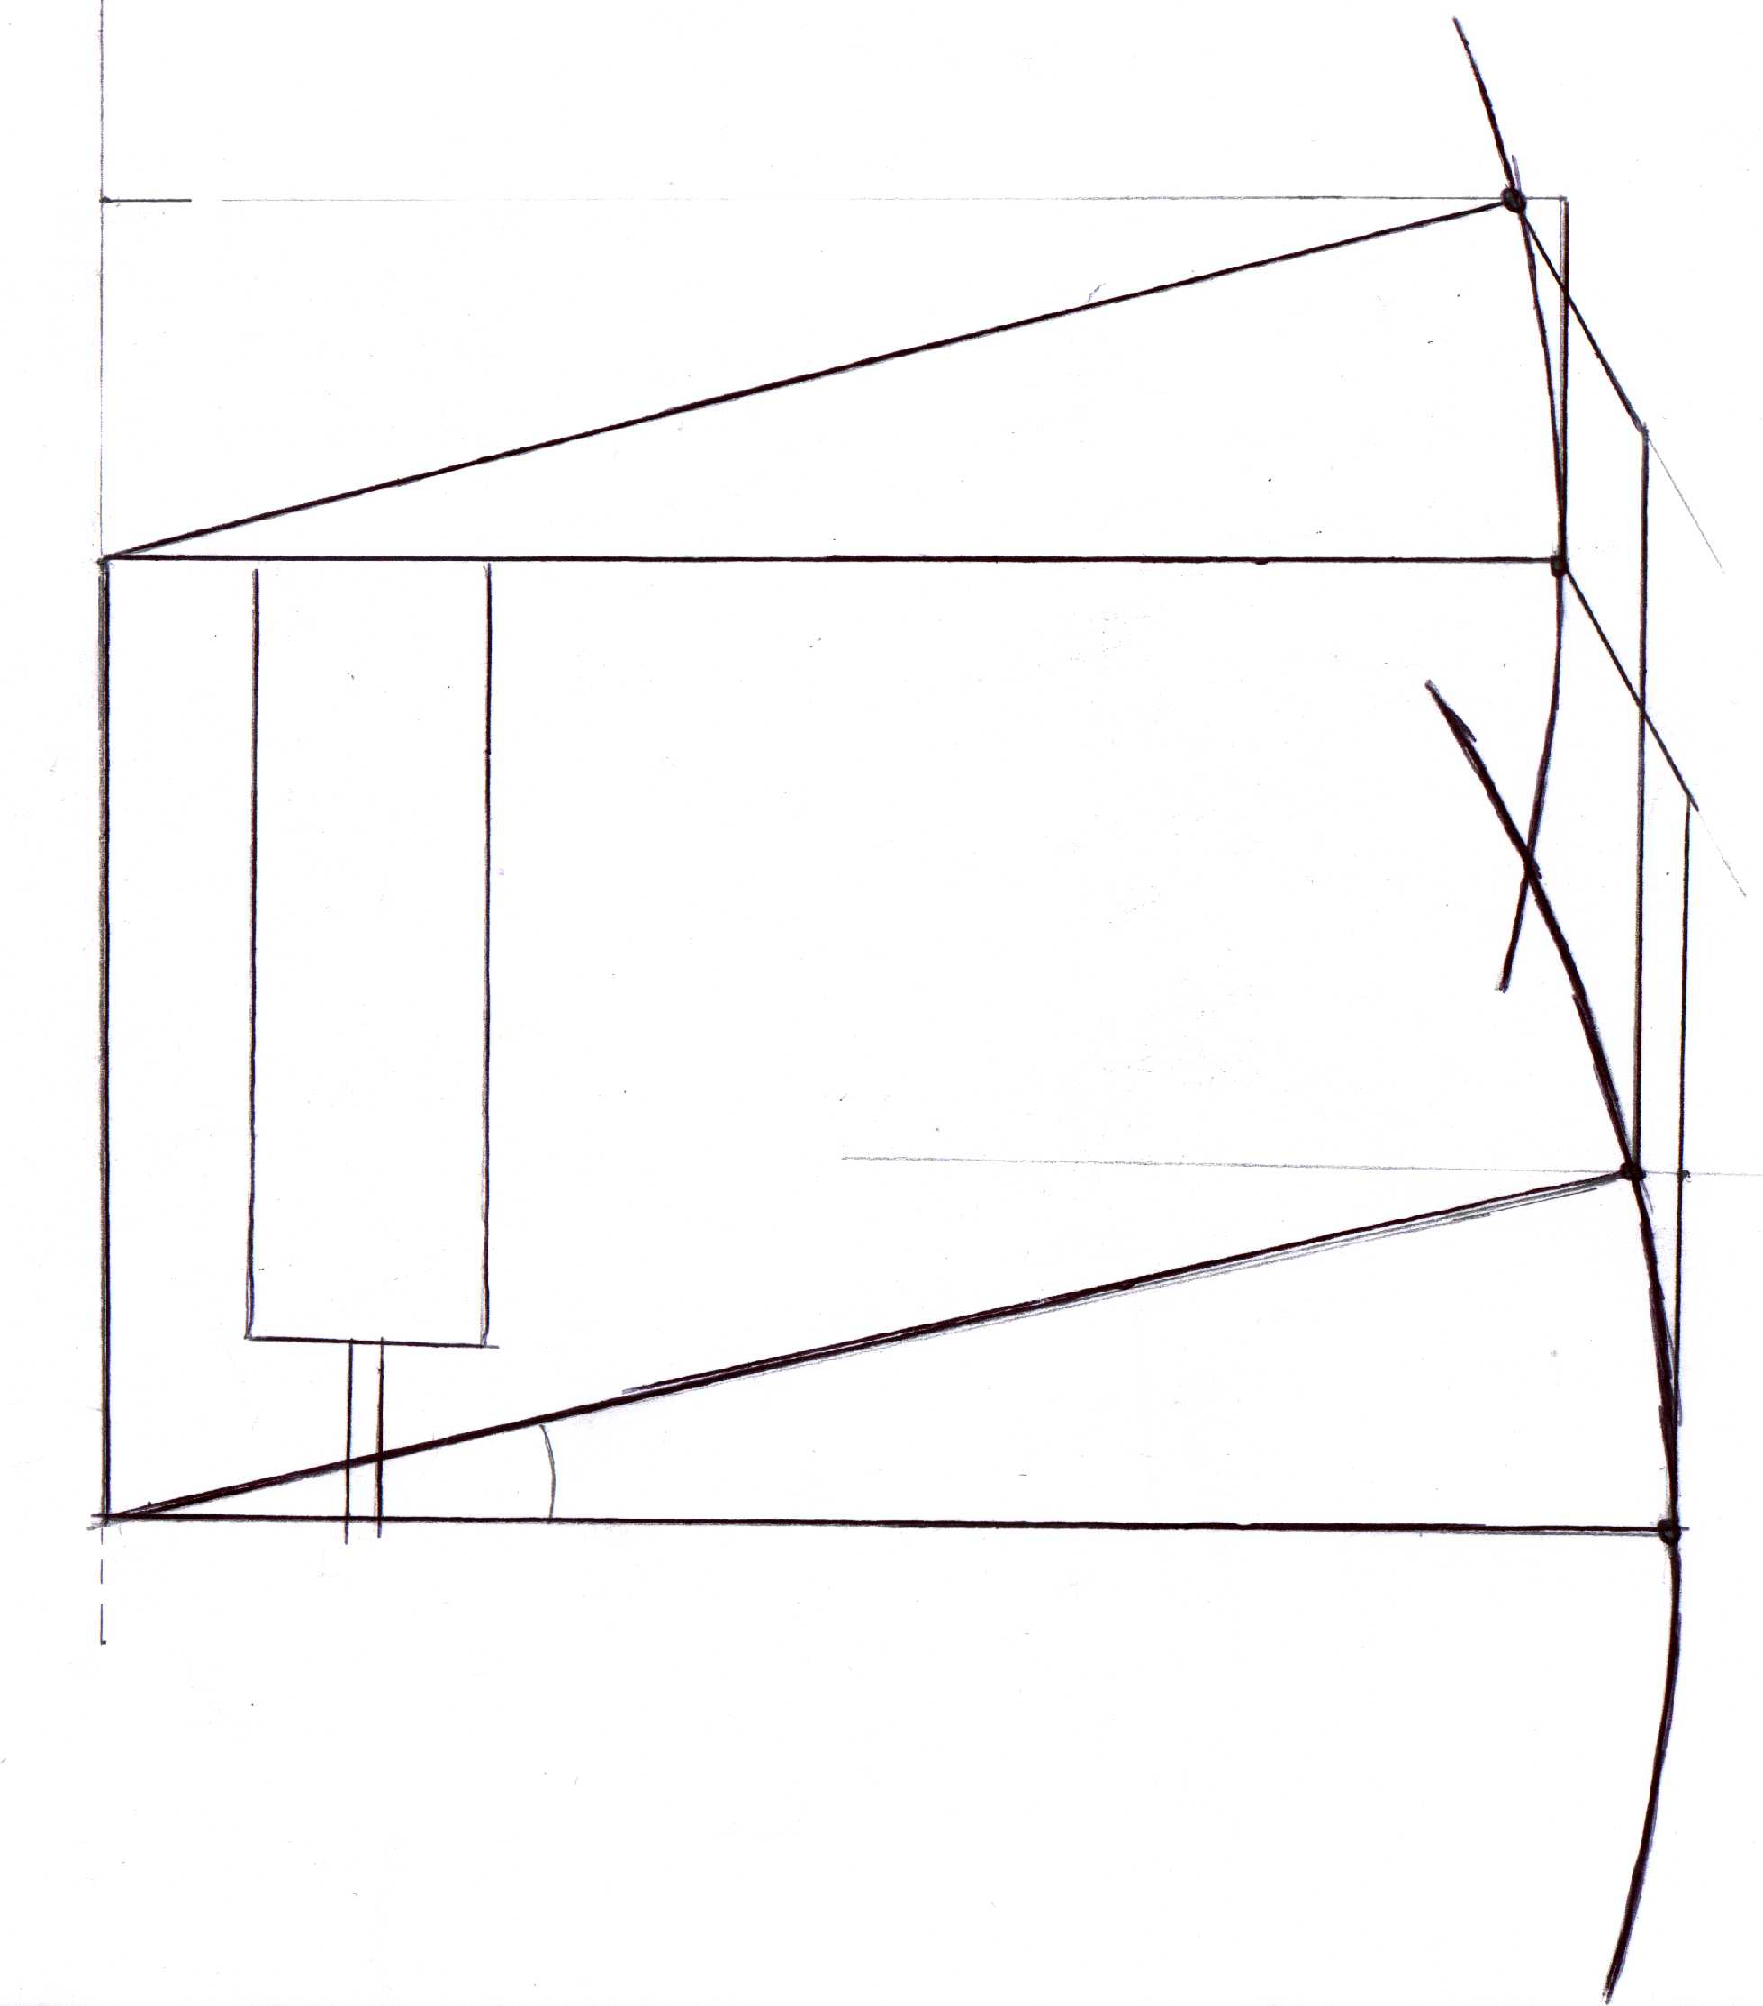
.5in displacement (scrub)
12in
11in
9in
3in travel height
Shock
1.5in
Travel
Figure 11: Geometric sketch of final design; distances, lengths, and angles.
Our next task after coming up with our final design, was to determine how we would mount the suspension system on to this newly designed honeycomb composite body. After some analysis, it was determined that four plates would be needed to mount the suspension on to the body. These four plates were the pivot points for the suspension system. However, it was further analyzed that a fully connect bulkhead would be needed to increase durability strength for the system. After this was done, mechanical drawing of all the major parts was sketch out and drawn use the ProE software. A sample drawing of the bulkhead can be seen in figure 11 below. Also, a subassembly drawing of the system can be view in appendix C. All other engineering drawings of the different parts can be viewed in appendix C.

The tasks completed for the year include:
- WBS
- Budget
- Final Design
- Shock selection
- Suspension mounting system
- Simulated Drawings
- Minimizing Scrub
- Finalized engineering drawings

Unfinished tasks include:
- Composite material stress analysis
- Ordering Parts
- Machining parts
- Suspension performance analysis

Also, with assembly beginning next school year, our project budget analysis remained the same throughout both stages of the project. The budget analysis consists of a break down of all the prices that will be included in the production of the front suspension.

Budget:
- Bulk metal (aluminum/iron) 600.00
- Shocks 1200.00
- Wheels 1200.00
- Tires 1000.00
- Hardware (Bolts/Nuts) 300.00
- Steering linkage 500.00
- Steering Box 500.00
- Brake calipers 400.00
- Brake rotors 700.00
- Rotor hubs 800.00
- Brake lines 200.00
- Master cylinder 200.00
- Pedal Assembly 250.00
- Total 7850.00

The money used to construct Sunsation II will come from donations made by small companies and several large corporations. The purpose of this budget is to provide an estimate of the total cost of the front suspension. The prices are slightly inflated in order to make sure that the amount given will cover the design and construction of the suspension. The parts included on the budget are the essential components of the front suspensions. The front suspension group realizes that there maybe components not included on this budget/parts list hence the inflated prices, which allows the adding of parts without going over budget.

Second Phase
Due to the change in the schedule for the new solar car (Sunsation II), there was also a change in our schedule and required demands from our front suspension team. The change came about because our sponsor (Dr. Harrison) really didn’t feel that the team as a whole had a well enough understanding to design a new car with a composite body. So in luau of time and understanding, the new solar car will be designed and built very similar to the existing solar car that we have now. The new car will not be made of unibody composite material, but will be built on a chromoly tube frame like that of Sunsation I. This design is purely used to mount the designed suspension components, and solve any problems with spacing of the parts. This design is only a proposed, not final, used to model our front suspension design. The diameter of the chromoly tube fame is 1.25”; this dimension is the same as that on the existing car “Sunsation I”.
The outside body designed for the initially desired solar car will remain the same, for the design air foil and array layout. So the second phase of the finalizing design specifications and ProE engineering drawings.
The incorporation of the steering design and wheel assembly were also two task set for this second semester but was unsuccessful due lack of AutoCAD knowledge. We tried to import and even transfer the exiting steering system and wheel assembly, which turned out to be very difficult and unsuccessful. However, after further review and brainstorming, it seems that the existing steering system and the wheel would be a good incorporation for now with the change of the new solar car design. If we do figure out how to transfer files of AutoCAD into our main engineering design package ProE, it would help with the layout of our design drawings.
But for now, the secondary parts, and steering system and wheel assembly can be found on file in the solar car trailer on the computer.
Conclusion
Although we were not required to start building during this second phase, our team was still required to develop the theory of our modified design, complete with conceptual designs and detailed engineering drawings to be used in the machining and assembly of next year’s solar car.
In conclusion, this second phase has definitely taken its toll on our team. We have definitely put in hours and hours of hard work to not on develop a new design, but ensure its ability to perform in next year’s solar car challenge.

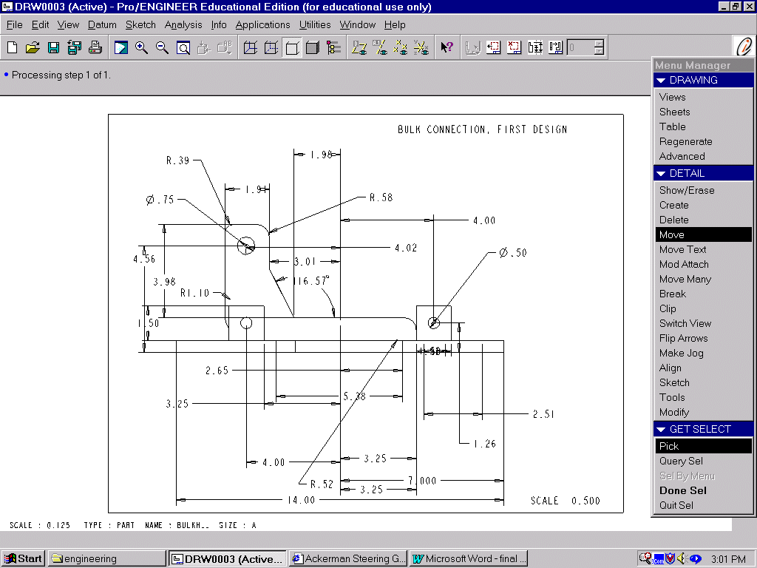SUSPANSION PARTS (drawings)

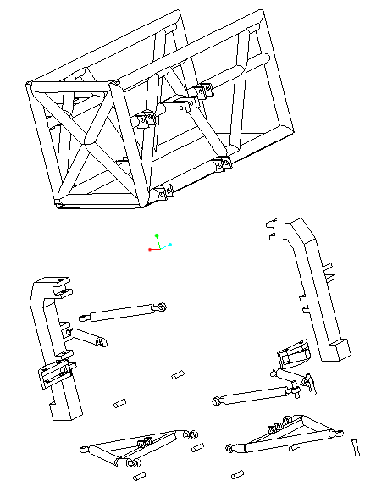

Chassis

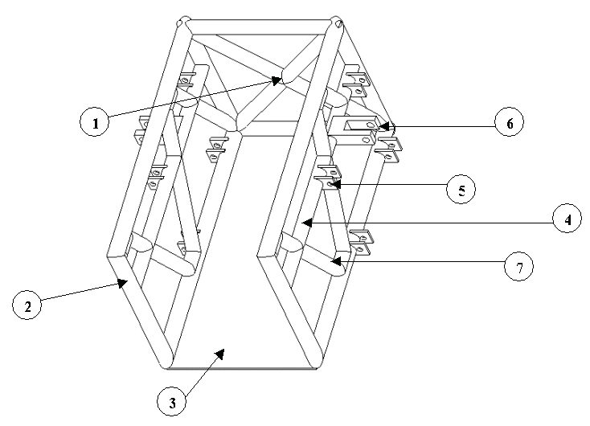

The above figure shows the possible chassis design of the new car.

Strut

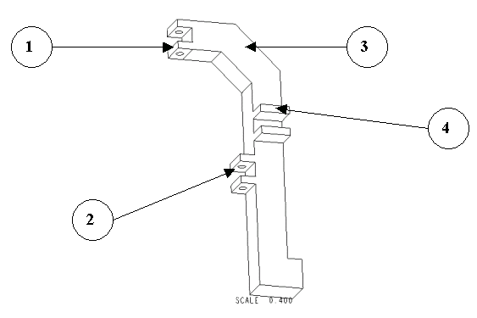
The figure above is an illustration of our team strut (connection arm) design.

Lower A-arm
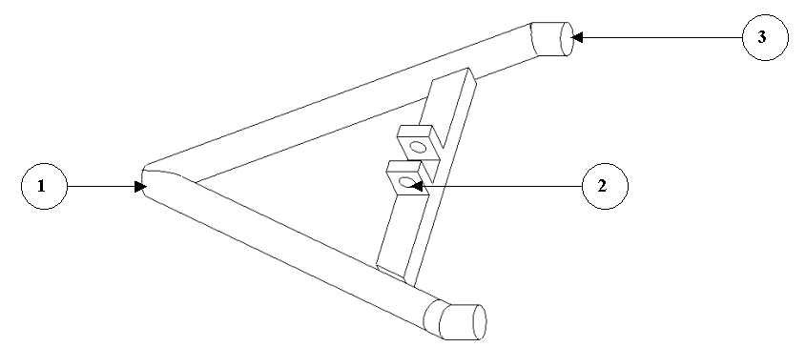

Upper Link

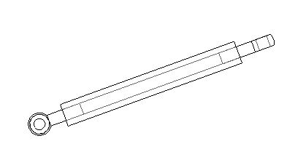

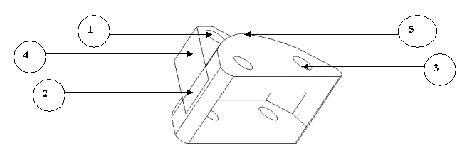
Rotational Link

Figure 13

Figure 14

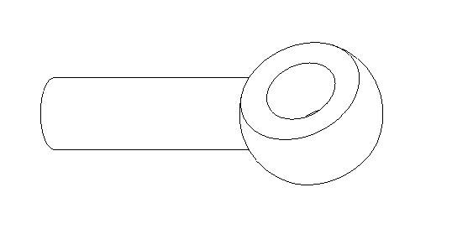
Hymne Joint

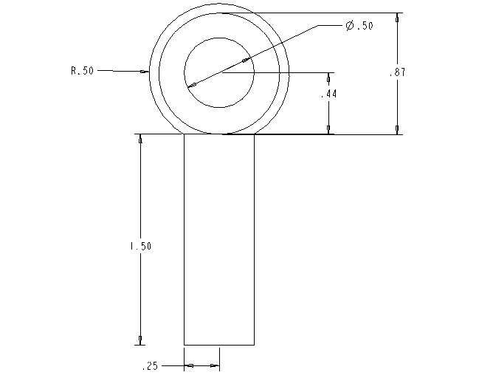
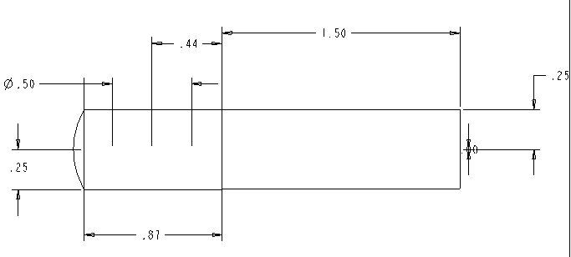
Figure 17

Figure 16

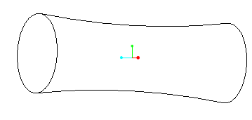
Shim

The figure above is an illustration of the type of shim that will be needed for our front suspension design. Similar to the hyme joint the shim will have to be fabricated by an outside company.

